

**Document Title** Phase 1 Test Plan

**Project:** CAN (Controller Area Network) Elevator

**Revision** 1.0

**Date Created** May 17, 2017

**Department** School of Engineering and Information Technology

**Program** Electronic Systems Engineering

**Author** Kevin Hartwig

**Reviewers** James Sonnenberg, Ovi Ofrim

**Date of Current Spec** May 17, 2017

# 

|  |  |  |
| --- | --- | --- |
| **Revision** | **Description of Change** | **Effective Date** |
| 1.0 | Initial Release | March 11, 2016 |
|  |  |  |
|  |  |  |
|  |  |  |
|  |  |  |

# **1. Introduction__________________________**

## **1.1 Objective:**

Provide a detailed testing plan for all components and modules designed and implemented in Phase 1 of the project.

## **1.2 System Block Diagram:**

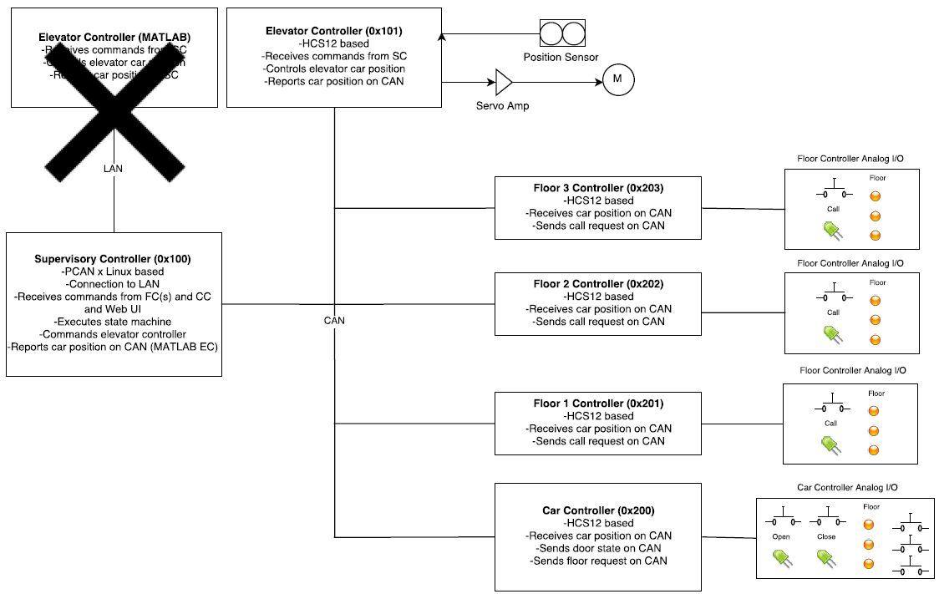

Figure 1: System Block Diagram, Courtesy of Tommy Abdallah

## **1.3 Test Plan Breakdown:**

***1. Call Station and Elevator Car Testing***

1. Test the up/down switches and lights of each call station
2. Test the open/close switches and lights of the elevator car
3. Test the floor selection switches and lights of the elevator car

***2. System Level Testing***

1. Test elevator system to ensure it covers at least three floors, with one CAN node per floor
2. Test the LCD or 7-segment display to ensure it displays the current location of the elevator
3. Test the system capability to detect the location of the elevator car (with the distance sensor) and its ability to distribute this information to all call-stations for displaying on the LCD or 7-segment display
4. Ensure the system can detect up/down request at any floor and switch on the respective LED
5. Ensure the system can detect floor selection at any floor and switch on the respective LED
6. Ensure the system can detect a door open/close request at any floor and switch on the respective LED

# **DETAILED TEST PLAN________________**

1. **Call Station and Elevator Car Testing**
   1. Test up/down switches and lights of each call station

For each floor, use the call switch to call the elevator car. Indicate functionality of the call switch and the indicator lights with a ✓ or X.

|  |  |  |  |  |  |  |
| --- | --- | --- | --- | --- | --- | --- |
| **Call Station** | **Call Switch** | **Call Indicator LED** | **Floor Indicator LED**  **(1) (2) (3)** | | | **Notes** |
| *Floor 1* |  |  |  |  |  |  |
| *Floor 2* |  |  |  |  |  |  |
| *Floor 3* |  |  |  |  |  |  |

* 1. Test the open/close switches and lights of the elevator car

Use the open/close switches. Indicate functionality of each switch and the associated indicator lights with a ✓ or X.

|  |  |  |  |  |
| --- | --- | --- | --- | --- |
| **Switch**  **(open) (close)** | | **LED**  **(open) (close)** | | **Notes** |
|  |  |  |  |  |

* 1. Test the floor selection switches and lights of the elevator car

Use the floor switches to move the elevator car to each floor. Indicate functionality of each switch and the floor indicator lights with a ✓ or X.

|  |  |  |  |  |  |  |
| --- | --- | --- | --- | --- | --- | --- |
| **Call Switch**  **(1) (2) (3)** | | | **Floor Indicator Light**  **(1) (2) (3)** | | | **Notes** |
|  |  |  |  |  |  |  |

1. **System Testing**
   1. Test elevator system to ensure it covers at least three floors, with one CAN node per floor

*If Section 1 of testing was completed successfully (i.e., call station and elevator testing was completed for each of the three floors), then this part is already complete.*

* 1. Test the LCD or 7-segment display to ensure it displays the current location of the elevator

Move the elevator car to each floor and indicate the functionality of the 7-segment display with a ✓ or X.

|  |  |  |  |
| --- | --- | --- | --- |
| **7-Segment for Floor:**  **(1) (2) (3)** | | | **Notes** |
|  |  |  |  |

* 1. Test the system capability to detect the location of the elevator car (with the distance sensor) and its ability to distribute this information to all call-stations for displaying on the LCD or 7-segment display

Move the elevator car to each floor ***from the supervisory controller***. Indicate the functionality of the supervisory controller’s floor status monitor with a ✓ or X. This will confirm the functionality of the distance sensor and the interpretation of this data by the supervisory controller. Also indicate that each call station receives the floor status data.

|  |  |  |  |  |  |
| --- | --- | --- | --- | --- | --- |
| **Call Station** | **Supervisory Controller Floor Status** | **Call Station – Data Received?**  **Floor 1 Floor 2 Floor 3** | | | **Notes** |
| *Floor 1* |  |  |  |  |  |
| *Floor 2* |  |  |  |  |  |
| *Floor 3* |  |  |  |  |  |

* 1. Ensure the system can detect call request at any floor and switch on the respective LEDs

*Follow the steps below to test all call requests and LEDs comprehensively.*

Move the elevator to Floor 1. Initiate a call request at Floor 1.

|  |  |  |  |  |
| --- | --- | --- | --- | --- |
| **Supervisory Controller Floor Status** | **Call Station LEDs**  **(all should indicate Floor 1)**  **Floor 1 Floor 2 Floor 3** | | | **Notes** |
|  |  |  |  |  |

Car should be at Floor 1. Initiate a call request at Floor 2.

|  |  |  |  |  |
| --- | --- | --- | --- | --- |
| **Supervisory Controller Floor Status** | **Call Station LEDs**  **(all should indicate Floor 2)**  **Floor 1 Floor 2 Floor 3** | | | **Notes** |
|  |  |  |  |  |

Car should be at Floor 2. Initiate a call request at Floor 3.

|  |  |  |  |  |
| --- | --- | --- | --- | --- |
| **Supervisory Controller Floor Status** | **Call Station LEDs**  **(all should indicate Floor 3)**  **Floor 1 Floor 2 Floor 3** | | | **Notes** |
|  |  |  |  |  |

Car should be at Floor 3. Initiate a call request at Floor 2.

|  |  |  |  |  |
| --- | --- | --- | --- | --- |
| **Supervisory Controller Floor Status** | **Call Station LEDs**  **(all should indicate Floor 2)**  **Floor 1 Floor 2 Floor 3** | | | **Notes** |
|  |  |  |  |  |

Car should be at Floor 2. Initiate a call request at Floor 1.

|  |  |  |  |  |
| --- | --- | --- | --- | --- |
| **Supervisory Controller Floor Status** | **Call Station LEDs**  **(all should indicate Floor 1)**  **Floor 1 Floor 2 Floor 3** | | | **Notes** |
|  |  |  |  |  |

Car should be at Floor 1. Initiate a call request at Floor 3.

|  |  |  |  |  |
| --- | --- | --- | --- | --- |
| **Supervisory Controller Floor Status** | **Call Station LEDs**  **(all should indicate Floor 3)**  **Floor 1 Floor 2 Floor 3** | | | **Notes** |
|  |  |  |  |  |

Car should be at Floor 3. Initiate a call request at Floor 1.

|  |  |  |  |  |
| --- | --- | --- | --- | --- |
| **Supervisory Controller Floor Status** | **Call Station LEDs**  **(all should indicate Floor 1)**  **Floor 1 Floor 2 Floor 3** | | | **Notes** |
|  |  |  |  |  |

* 1. Ensure the system can detect floor selection at any floor and switch on the respective LED.

*Follow the steps in the table below to test floor selection at each floor comprehensively. All floor selections in this part are done* ***from the car controller****.*

|  |  |  |
| --- | --- | --- |
| **Instruction** | **Floor Indicator** | **Notes** |
| 1. Move the car to Floor 1. Select Floor 1 with its designated switch. |  |  |
| 1. Car should be at Floor 1. Select Floor 2 with its designated switch. |  |  |
| 1. Car should be at Floor 2. Select Floor 3 with its designated switch. |  |  |
| 1. Car should be at Floor 3. Select Floor 2 with its designated switch. |  |  |
| 1. Car should be at Floor 2. Select Floor 1 with its designated switch. |  |  |
| 1. Car should be at Floor 1. Select Floor 3 with its designated switch. |  |  |

* 1. Ensure the system can detect a door open/close request at any floor and switch on the respective LED

Move the car to each floor. At each floor, indicate the functionality of the open/close switches and LEDs.

|  |  |  |  |  |  |
| --- | --- | --- | --- | --- | --- |
| **Call Station** | **Open Switch** | **Door Open Indicator LED** | **Close Switch** | **Door Closed Indicator LED** | **Notes** |
| *Floor 1* |  |  |  |  |  |
| *Floor 2* |  |  |  |  |  |
| *Floor 3* |  |  |  |  |  |